Curriculum Vitae
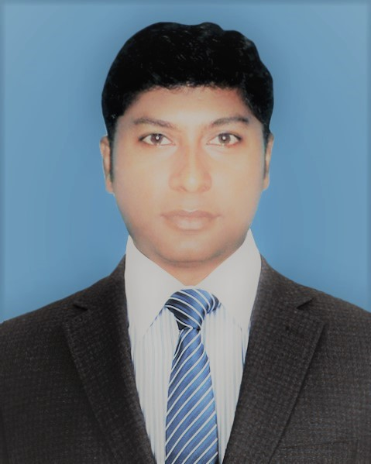
Krishnendu Sen
Contact: 7-Moinuddin Ahamed lane
Mill para, Post: Mohini Mills,
Dist: Kushtia
Cell: 01711-506791
E-mail: bapysen@gmail.com

Career Objective:

“To use my skills in the best possible way for achieving the company’s goals”

Competency:

- Customer Service & Stakeholder Management
- Sales & Distribution, Event Sales Management & Trade Marketing
- Partner Management, Distribution & Retail Sales
- Campaign Management & Digital Awareness
- Market Research Analysis & Distribution Expansion
- Business Planning & MFS Drive
- Distribution House Development & FF Supervision
- Agency Coordination & Ensure Brand present

Professional Exposure:

Territory Manager (Sales & Distribution)
August 2016 – March 2020
Grameenphone Ltd (Business circle, Rajshahi)

Key Deliverables:

- Achieving Territory POS Visit and Sales target
- Distribution Coverage expansion & ensures last mile footprint
- Motivating Channel Partners & increased advocacy
- Ensured Market visibility and Brand Presence
- Achievement of the Distribution House Sales & Compliance KPIs
- Handling Distribution House Operation & Audit
- Conduct Corporate office & provide solution urgent basis
- Distribution Field Force motivation, training and development
- Managing GP Express & SRP’s for Digital adaption
- Product availability & Spreading in market (i.e. SIM KIT, Rep KIT, ERS, SC, Device & FS)
- Driving MFS business and problem solving
- Quick Campaigns Execution & Channel development
- Cluster & BTS based Event execution & increased revenue
- Making Competition combat plan for increase market share
- Ensured YnY double digit Growth of major permeates [i.e. Reload-14%, Trigger (Voice & Data)-53%]
- Information Management & Reporting

Territory Officer (Senior Executive) Distribution & Retail Sales
August 2008 - July 2016
Grameenphone Ltd (Business Circle, Khulna)

Key Deliverables:

- Attained Territory Sales target through daily POS visit
- Ensured proper distribution of products and implemented of retail channel activities
- Prepared own market visit plan, retail execution, Campaign execution & Distribution extension
- Regular basis lead and motivated the retailers to strongly promote GP and induce push sales
- Provided all necessary support to retailers according to channel development plans
- Provided feedback on market activities to relevant people for coordinated planning
- Established strong trade relationship with Channel partners

Customer Manager (Customer Management Division)
August 2005 - March 2008
Grameenphone Limited
Khulna Region

Key Deliverables:

- Coordinated all after Sales activities, with retention, loyalty and back office for customer satisfaction
- Handled critical issues and solved rapidly
- Created Customer motivation & build up positive mindset towards company
- Established superior relation with local community especially retail channel partners
- Connection retailed through customers (SIM, ERS & SC etc.)
- Analyzed and investigating price, demand and competition
- Accumulated competition activity & communicate through concern end
- Checked and monitored Events activity & ensured greater performance
- Executed all campaign towards Customer
- Managed proper Stock keeping & reporting

Training Attended:

- Strategic Negotiation, Everyday Leadership & Efficient Time Management (LinkedIn) Year :2019
- Growth Mindset, Work Smarter (Lynda.com) Year:2108
- Sales Excellence Training Year: 2017, Duration :3 days
- STEP Training (basic sales) Year: 2015, Duration: 2 days
- Sales Master Training (Tomorrow’s Sales leaders) Year: 2014, Duration: 03 days
- TOP GUN Academy (Sales Operations) Year: 2009, Duration: 05 days
- Communication Skill Year: 2007, Duration: 01 day
- CIC Training Year: 2007, Duration: 01 day

Education:

MBA, Major-Marketing
Passing Year: 2010
CGPA: 3.43 (Out of 4.00)
University: Darul Ihsan University

MSS in Political Science
Passing Year: 2001
Class: Second
University: National University

Key Achievements:

- Nationally 9th position in Distribution index out of 409 Distribution House (1-30 Nov’19)
- Achieved Sales Championship award Q3-2019
- Regionally Best performance award December’2018
- Rewarded as a CBH special award on consistent performance in Q3-2017
- Rewarded of Commercial Achiever’s Club (Performing award) Year-2017
- Regionally Best Territory Manager (Sales, Distribution) Year-2017
- Rewarded of daily re-registration competition in Grameenphone, Year-2016
- Nationally Best Territory Officer (Sales Achievement Award) in Grameenphone, Year -2011
- Regionally Best Territory Officer of GP C-200 Handset sales with BRAC Member, Year-2011
- Nationally Best Territory Officer (Sales Achievement Award) in Grameenphone, Year -2010
- Best Customer Manager (Customer Service) in Grameenphone Service Desk, Year -2007
- Rewarded on Valuable Contribution of market inside (Market Research & Analyses) Year-2006

Personal Information:

Name : Krishnendu Sen
Father’s Name : Amal Krishna Sen
Mother’s Name : Chitra Sen
Date of birth : 04th February 1977
Nationality : Bangladeshi by birth
Marital status : Married
Religion : Sanatan (Hindu)

Permanent Address:
Village: 7 No. Moinuddin Ahmad lane,
Mill Para,
Post: Mohini Mills,
P.S.: Kushtia Sadar
District: Kushtia

Present Address:
Village: 7 No. Moinuddin Ahmad lane,
Mill Para,
Post: Mohini Mills,
P.S.: Kushtia Sadar
District: Kushtia

Computer Literacy:

Familiar with MS Word, MS Excel & MS Power- Point, Email & Internet operations

Personal Attributes:

- Excellent Communication and interpersonal sensitivity
- Strong Analytical ability with creative mindset
- Effectively meet deadlines, achieve targets and work under pressure
- Good in planning, organizing, leading and self-driven
- Team playing, target oriented and consumer focused
- Multitasking ability
- Effective presentation of complex issues

Please find the following information:
- While applying candidate have to mention why he apply to Honda and why he think himself an outstanding candidate for this job?

Ans: Honda is the world famous organization, so it has been my long dream to be an employee of this famous organization. I think my dedication, passion for business, Team playing ability as well as sales, Distribution, Dealer management and channel development experience.

- While applying must mention whether having driving license or not?
Ans: Yes I have driving license.

References:
M H Murtaza
Director Sales & Marketing
Healthcare Pharmaceuticals limited
Dhaka
Mobile: +88 01977157500

Md. Ahsan Habib
General Manager-Head of Planning (Distribution & Retail)
Business Circle, Dhaka
Commercial Division
Grameenphone Ltd
Mobile : +88 01711501381

Date: 30.09.2020 Signature: Krishnendu

